| **SCHOOL OF SCIENCE AND HUMANITIES** | | | **DEPARTMENT OF BASIC SCIENCE** | |
| --- | --- | --- | --- | --- |
| **Program Name : B.Tech** | | **Assignment Type : LAB** | | **Academic Year: 2025-2026** |
| **Course Coordinate Name :** | | **Dr. Madhu Kumar** | | |
| **Instructor Name :** | | **Dr. Randeep Singh** | | |
| **Course Code** | **25SCI202BS106** | **Course Title** | **Computional Chemistry and Biology** | |
| **Year/Sem** | **1-1** | **Regulation** | **R25** | |
| **Date&Day of Assignment** | **18/08/2025** | **Time(s):** | **1-3 PM** | |
| **Duration** | **2 Hours** | **Applicable Batches** | **All Batches CSE** | |
| **Assignment Number : 02/12** | | | | |
| **Molecular Modeling of Protein Structure from Raw Sequence** | | | | |

| **Name:** | **Gandra Bala Aditya Reddy** |
| --- | --- |
| **Hall Ticket No. :** | **2503A51226** |
| **Batch :** | **42** |
| **Protein Name :** | **Insulin** |

**Problem 1 :**   
The 3D structure of **Insulin** is needed for study, but we do not have an experimental structure for the exact sequence. A computer model must be built.

**Aim :**To build and validate a 3D model of **Insulin** using **SWISS-MODEL**, and analyze it with **Swiss-PdbViewer**.

**Objective :**

1. Get the **Insulin** protein sequence.
2. Build a homology model in SWISS-MODEL.
3. Validate the model using a **Ramachandran plot** and quality scores.
4. Download the structure in **PDB format**.
5. Visualize the structure and active regions in Swiss-PdbViewer.

**Procedure**

1. Retrieve the FASTA sequence of Insulin from UniProt.
2. Upload the sequence to **SWISS-MODEL** and search for templates.
3. Build the 3D model using the best template (high sequence identity).
4. Record GMQE from SWISS-MODEL.
5. Download the model in **PDB format**.
6. Check the **Ramachandran plot** for residue distribution.
7. Open the model in **Swiss PDBViewer**, show helices and sheets, and visualize the heme-binding region.
8. Take screenshots for the report.

**Result :**

* Uniprot ID : P01308
* GMQE: 0.55
* Ramachandran plot:   
   favored % : 72.83%

**Solution to Problem :**

A reliable 3D model of **Insulin** was successfully built and validated. The quality checks show that the model is acceptable and suitable for further studies.

**Outcome :**

The generated model of Insulin can be used for **visualization, structural analysis.**

**Structure :**

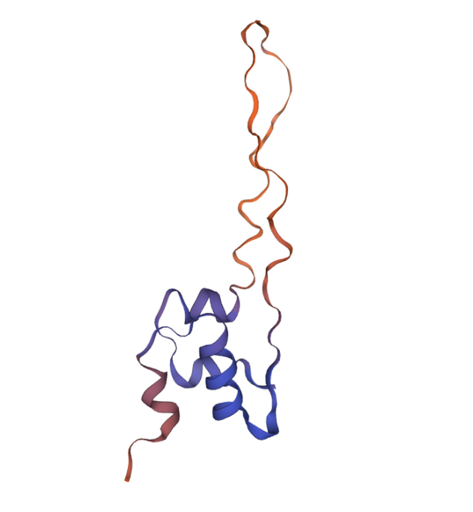

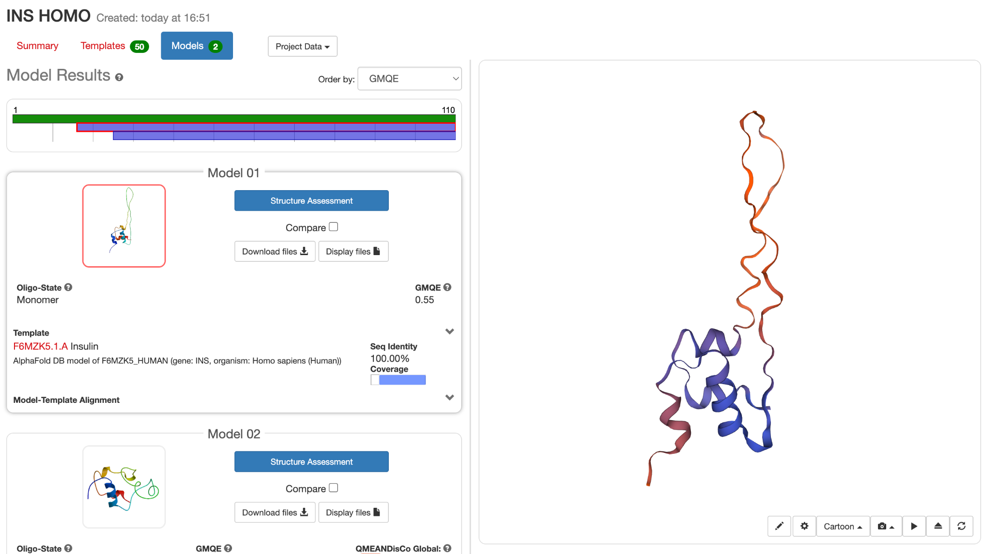

**Ramachandran Plot :**

